3.35 Main Question (สำหรับแสดงข้อสอบ)

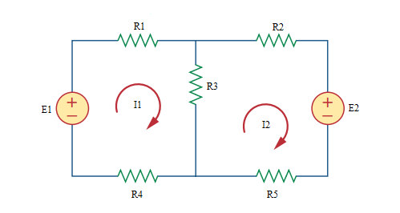

Given *E*1 = 4 V, *E*2 = 6 V, *R*1 = 4 Ω, *R*2 = 2 Ω, *R*3 = 8 Ω, *R*4 = 5 Ω, *R*5 = 3 Ω.

Find

Variables (สำหรับเขียนโค้ดเพื่อหาคำตอบ)

Random variables

E1 = {1:10}; E2 = {1:10};

R1 = {1:10}; R2 = {1:10}; R3 = {1:10}; R4 = {1:10}; R5 = {1:10};

Global variables

#E1 = 4; E2 = 6; R1 = 4; R2 = 2; R3 = 8; R4 = 5; R5 = 3;

Z11 = R1+R3+R4; Z12 = -R3; Z22 = R2+R3+R5;

V1 = E1; V2 = -E2;

D = Z11\*Z22-Z12\*Z12;

D1 = V1\*Z22-V2\*Z12;

D2 = Z11\*V2-Z12\*V1;

I1 = D1/D; I2 = D2/D;

Part (กรอกคำตอบ)

1. *I*1 = I1 = 0.0255 A

2. *I*2 = I2 = -0.4459 A

3.36 Main Question (สำหรับแสดงข้อสอบ)

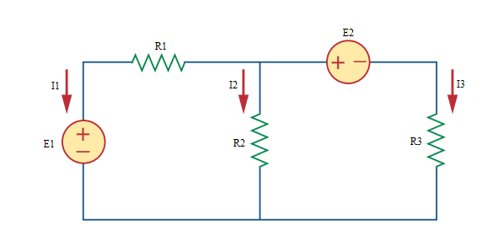

Given *E*1 = 12 V, *E*2 = 10 V, *R*1 = 4 Ω, *R*2 = 6 Ω, *R*3 = 2 Ω.

Find

Variables (สำหรับเขียนโค้ดเพื่อหาคำตอบ)

Random variables

E1 = {1:20}; E2 = {1:20};

R1 = {1:10}; R2 = {1:10}; R3 = {1:10};

Global variables

#E1 = 12; E2 = 10; R1 = 4; R2 = 6; R3 = 2;

Z11 = R1+R2; Z12 = -R2; Z22 = R2+R3;

V1 = E1; V2 = -E2;

D = Z11\*Z22-Z12\*Z12;

D1 = V1\*Z22-V2\*Z12;

D2 = Z11\*V2-Z12\*V1;

I1 = D1/D; I2 = D2/D;

Part (กรอกคำตอบ)

1. *I*1 = I1 = -0.8182 A

2. *I*2 = I2 = 1.4546 A

2. *I*3 = I3 = -0.6364 A

3.37 Main Question (สำหรับแสดงข้อสอบ)

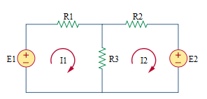

Given *E*1 = 4 V, *E*2 = 6 V, *R*1 = 4 Ω, *R*2 = 2 Ω, *R*3 = 8 Ω.

Find

Variables (สำหรับเขียนโค้ดเพื่อหาคำตอบ)

Random variables

E1 = {1:10}; E2 = {1:10};

R1 = {1:10}; R2 = {1:10}; R3 = {1:10};

Global variables

#E1 = 4; E2 = 6; R1 = 4; R2 = 2; R3 = 8;

Z11 = R1+R3; Z12 = -R3; Z22 = R2+R3;

V1 = E1; V2 = -E2;

D = Z11\*Z22-Z12\*Z12;

D1 = V1\*Z22-V2\*Z12;

D2 = Z11\*V2-Z12\*V1;

I1 = D1/D; I2 = D2/D;

Part (กรอกคำตอบ)

1. *I*1 = I1 = -0.1429 A

2. *I*2 = I2 = -0.7143 A

3.40 Main Question (สำหรับแสดงข้อสอบ)

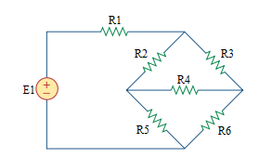

Given *E*1 = 10 V, *R*1 = 2 Ω, *R*2 = 1 Ω, *R*3 = 4 Ω, *R*4 = 5 Ω, *R*5 = 3 Ω, *R*6 = 3 Ω.

Find

Variables (สำหรับเขียนโค้ดเพื่อหาคำตอบ)

Random variables

E1 = {1:10};

R1 = {1:10}; R2 = {1:10}; R3 = {1:10}; R4 = {1:10}; R5 = {1:10}; R6 = {1:10};

Global variables

#E1 = 10;

#R1 = 2; R2 = 1; R3 = 4; R4 = 5; R5 =3; R6 =3;

Z11 = R1+R2+R5; Z12 = -R2; Z13 = -R5;

Z21 = Z12; Z22 = R2+R3+R4; Z23 = -R4;

Z31 = Z13; Z32 = Z23; Z33 = R4+R5+R6;

V1 = E1; V2 = 0; V3 = 0;

D = Z11\*Z22\*Z33+Z12\*Z23\*Z31+Z13\*Z21\*Z32-Z31\*Z22\*Z13-Z32\*Z23\*Z11-Z33\*Z21\*Z12;

D1 = V1\*Z22\*Z33+Z12\*Z23\*V3+Z13\*V2\*Z32-V3\*Z22\*Z13-Z32\*Z23\*V1-Z33\*V2\*Z12;

D2 = Z11\*V2\*Z33+V1\*Z23\*Z31+Z13\*Z21\*V3-Z31\*V2\*Z13-V3\*Z23\*Z11-Z33\*Z21\*V1;

D3 = Z11\*Z22\*V3+Z12\*V2\*Z31+V1\*Z21\*Z32-Z31\*Z22\*V1-Z32\*V2\*Z11-V3\*Z21\*Z12;

I1 = D1/D; I2 = D2/D; I3 = D3/D;

Part (กรอกคำตอบ)

1. *I*1 = I1 = 2.2427 A

2. *I*2 = I2 = 0.6860 A

2. *I*3 = I3 = 0.9235 A

3.41 Main Question (สำหรับแสดงข้อสอบ)

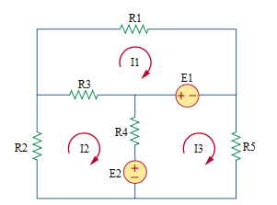

Given *E*1 = 6V, *E*2 = 8 V, *R*1 = 10 Ω, *R*2 = 4 Ω, *R*3 = 2 Ω, *R*4 = 1 Ω, *R*5 = 5 Ω.

Find

Variables (สำหรับเขียนโค้ดเพื่อหาคำตอบ)

Random variables

E1 = {1:10}; E2 = {1:10};

R1 = {1:10}; R2 = {1:10}; R3 = {1:10}; R4 = {1:10}; R5 = {1:10};

Global variables

#E1 = 6; E2 = 8;

#R1 = 10; R2 = 4; R3 = 2; R4 = 1; R5 =5;

Z11 = R1+R3; Z12 = -R3; Z13 = 0;

Z21 = Z12; Z22 = R2+R3+R4; Z23 = -R4;

Z31 = Z13; Z32 = Z23; Z33 = R4+R5;

V1 = E1; V2 = -E2; V3 = E2-E1;

D = Z11\*Z22\*Z33+Z12\*Z23\*Z31+Z13\*Z21\*Z32-Z31\*Z22\*Z13-Z32\*Z23\*Z11-Z33\*Z21\*Z12;

D1 = V1\*Z22\*Z33+Z12\*Z23\*V3+Z13\*V2\*Z32-V3\*Z22\*Z13-Z32\*Z23\*V1-Z33\*V2\*Z12;

D2 = Z11\*V2\*Z33+V1\*Z23\*Z31+Z13\*Z21\*V3-Z31\*V2\*Z13-V3\*Z23\*Z11-Z33\*Z21\*V1;

D3 = Z11\*Z22\*V3+Z12\*V2\*Z31+V1\*Z21\*Z32-Z31\*Z22\*V1-Z32\*V2\*Z11-V3\*Z21\*Z12;

I1 = D1/D; I2 = D2/D; I3 = D3/D;

Part (กรอกคำตอบ)

1. *I*1 = I1 = 0.3291 A

2. *I*2 = I2 = -1.0256 A

2. *I*3 = I3 = 0.1624 A